HTML

1. Are the HTML tags and elements the same thing?

ANS: No, tags and elements are not a same thing.

1. What are tags and attributes in HTML?

ANS: The attributes are define the character in html element and that is opening tag of an element and tags are starting and ending parts of html.

3. What are void elements in HTML?

ANS: A tag that does not completed called a void element in html. Ex. <br>.

4. What are HTML Entities?

ANS: The html entities is basically to define a symbol, emoji, number, etc.

5. What are different types of lists in HTML?

ANS: List is basically defining order number. There are 3 different types of lists in Html. (1) Order list (2) Unorder list (3) define list/ descriptive list

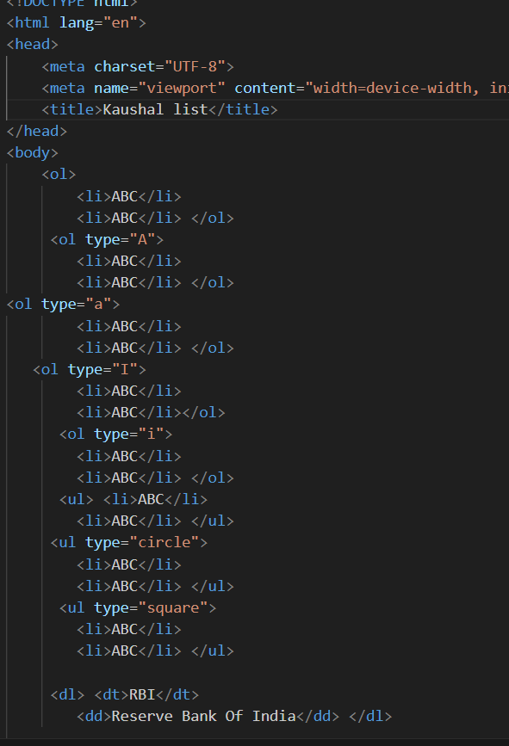

6. What is the ‘class’ attribute in HTML?

ANS: The class attribute is use for multiple name and it also use for class sheet.

7. What is the difference between the ‘id’ attribute and the ‘class’ attribute of HTML elements?

ANS. The id attribute is only use for one name and class is use for more then one name in elements.

8. What are the various formatting tags in HTML?

ANS. The various formatting tags is fonts, sizes, colors, etc. Ex. <b>, <i>, <u>.

9. How is Cell Padding different from Cell Spacing?

ANS. The cell padding use for increase the space inside the box and other side cell spacing is use to increase the space outside the box.

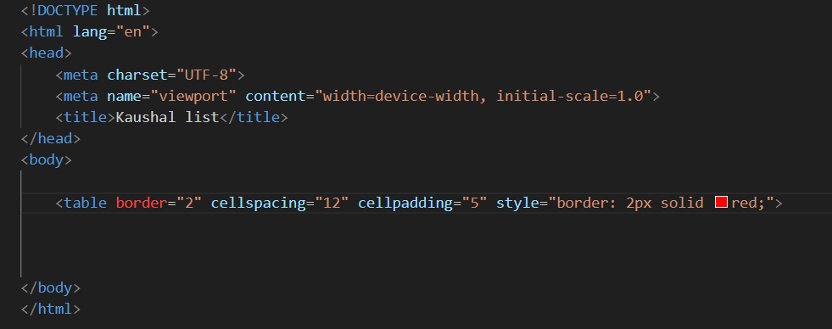

10. How can we club two or more rows or columns into a single row or column in an HTML table?

ANS: There are two tags which called rowspan and colspan. A rowspan is marge a row and colspan is marge a colums in tag of <td>.

11. What is the difference between a block-level element and an inline element?

ANS : A tag is comes in a single line it called a inline element and tag has start from the a new line it called a block-level element.

12. How to create a Hyperlink in HTML?

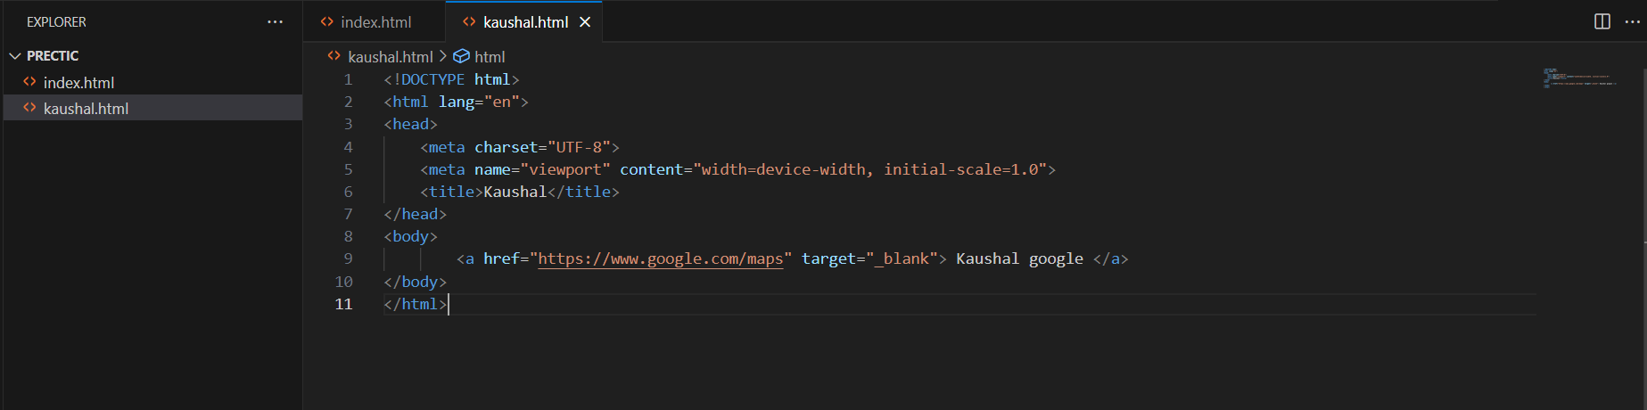ANS:

13. What is the use of an iframe tag?

ANS: The use of iframe tag is is load to another web site with page and also use for 2 web site run in a singal web page.

14. What is the use of a span tag? Explain with example?

ANS: The use of a span tag is doing a text colour without creating a new line.

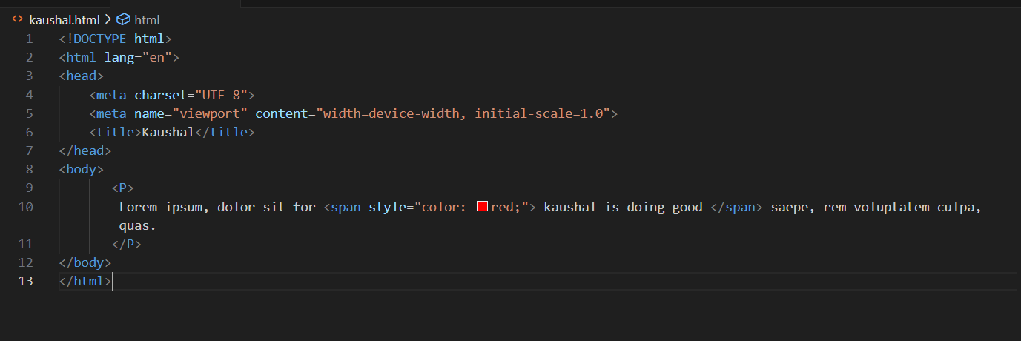

15. How to insert a picture into a background image of a web page?

ANS: 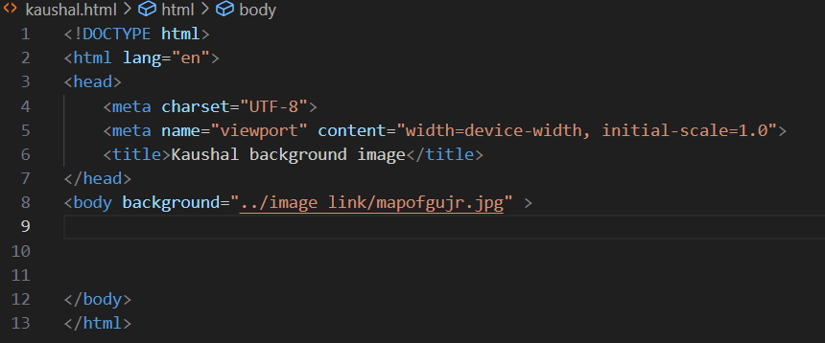

16. How are active links different from normal links?

ANS: Active links are currently use and open a web page and normal links are only for showing a code.

17. What are the different tags to separate sections of text?

ANS: The 6 heading tags is a different tage to type a heading and separate sections of text is new line Ex. <br>.

18. What is SVG?

ANS: SVG tags is use for making a circle in a table.

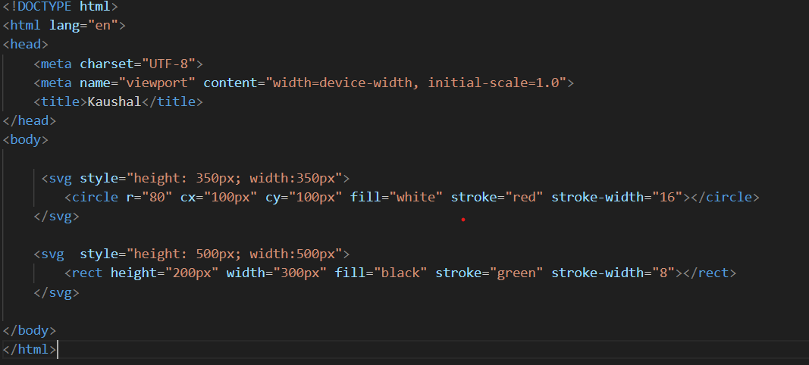

19. What is difference between HTML and XHTML?

ANS: HTML is create a web page and XHTML is only sticker and new version of HTML.

20. What are logical and physical tags in HTML?

ANS: The tag is use for a specific character and formatted is called physical tag. Ex. <b>, <i>, <big>, <small> and logical tags is written inside the tags and use for indicating to the visually impaired. Ex. <address>, <pre>, <strong>.